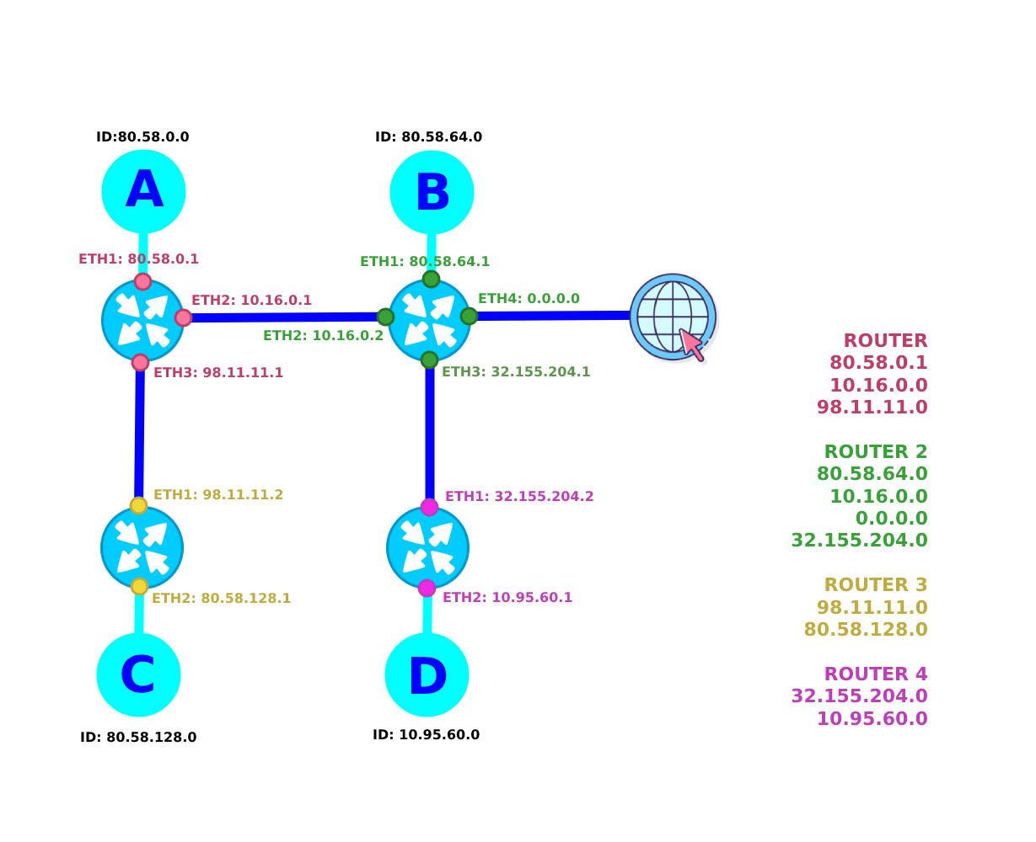



|  |  |  |  |  |
| --- | --- | --- | --- | --- |
| ROUTER 1 | | | | |
| RUTA | DESTINO | MÁSCARA | ETH | P.E. |
| RUTA A RED A | 80.58.0.0 | 18 | ETH1: 80.58.0.1 | 80.58.0.1 |
| RUTA A RED B | 80.58.64.0 | 18 | ETH2­: 10.16.0.1 | ETH2(B)  10.16.0.2 |
| RUTA A RED C | 80.58.128.0 | 18 | ETH3: 98.11.11.1 | ETH1(C)  98.11.11.2 |
| RUTA A RED D | 10.95.60.0 | 17 | ETH2­: 10.16.0.1 | ETH2(B)  10.16.0.2 |
| RUTA B RED 0 | 0.0.0.0 | - | ETH2­: 10.16.0.1 | ETH2(B)  10.16.0.2 |

|  |  |  |  |  |
| --- | --- | --- | --- | --- |
| ROUTER B | | | | |
| RUTA | DESTINO | MÁSCARA | ETH | P.E. |
| RUTA B RED A | 80.58.0.0 | 18 | ETH2­: 10.16.0.2 | ETH2(A) |
| RUTA B RED B | 80.58.64.0 | 18 | ETH1: 80.58.64.1 | 80.58.64.1 |
| RUTA B RED C | 80.58.128.0 | 18 | ETH1: 80.58.64.1 | ETH2(A) |
| RUTA B RED D | 10.95.60.0 | 17 | ETH3: 32.155.204.1 | ETH1(4) |
| RUTA B RED 0 | 0.0.0.0 | - | ETH4: X.X.X.X | X.X.X.Y |

|  |  |  |  |  |
| --- | --- | --- | --- | --- |
| ROUTER C | | | | |
| RUTA | DESTINO | MÁSCARA | ETH | P.E. |
| RUTA C RED A | 80.58.0.0 | 18 | ETH1: 98.11.11.2 | ETH3(A) |
| RUTA C RED B | 80.58.64.0 | 18 | ETH1: 98.11.11.2 | ETH3(A) |
| RUTA C RED C | 80.58.128.0 | 18 | ETH2: 80.58.128.1 | 80.58.128.1 |
| RUTA C RED D | 10.95.60.0 | 17 | ETH1: 98.11.11.2 | ETH3(A) |
| RUTA C RED 0 | 0.0.0.0 | - | ETH1: 98.11.11.2 | ETH3(A) |

|  |  |  |  |  |
| --- | --- | --- | --- | --- |
| ROUTER D | | | | |
| RUTA | DESTINO | MÁSCARA | ETH | P.E. |
| RUTA C RED A | 80.58.0.0 | 18 | ETH1: 32.155.204.2 | ETH3(B) |
| RUTA C RED B | 80.58.64.0 | 18 | ETH1: 32.155.204.2 | ETH3(B) |
| RUTA C RED C | 80.58.128.0 | 18 | ETH1: 32.155.204.2 | ETH3(B) |
| RUTA C RED D | 10.95.60.0 | 17 | ETH2: 10.95.60.1 | 10.95.60.1 |